Nama : Rozan Anggitan

QE - A

Object Oriented Programming (OOP)

SOAL PRIORITAS 1

1. Source Code :

public class Product {

String nama,deskripsi;

int harga,stock;

public void setName(String nama) {

this.nama = nama;

}

public String getName() {

return this.nama;

}

public void setDescription(String deskripsi) {

this.deskripsi = deskripsi;

}

public String getDescription() {

return this.deskripsi;

}

public void setPrice(int harga) {

this.harga = harga;

}

public double getPrice() {

return this.harga;

}

public void setStock(int stock) {

this.stock = stock;

}

public int getStock() {

return this.stock;

}

public void getInfo() {

System.out.println("Nama : " + this.getName());

System.out.println("Deskripsi : " + this.getDescription());

System.out.println("Harga : " + this.getPrice());

System.out.println("Stock: " + this.getStock());

}

{

System.out.println("================================");

}

public static void main(String[] args) {

Product Product1 = new Product();

Product1.setName("Coffee");

Product1.setDescription("This is coffee");

Product1.setPrice(15000);

Product1.setStock(10);

Product1.getInfo();

Product Product2 = new Product();

Product2.setName("Milk");

Product2.setDescription("This is fresh milk");

Product2.setPrice(25000);

Product2.setStock(10);

Product2.getInfo();

Product Product3 = new Product();

Product3.setName("Apple Juice");

Product3.setDescription("This is juice");

Product3.setPrice(18000);

Product3.setStock(20);

}

}

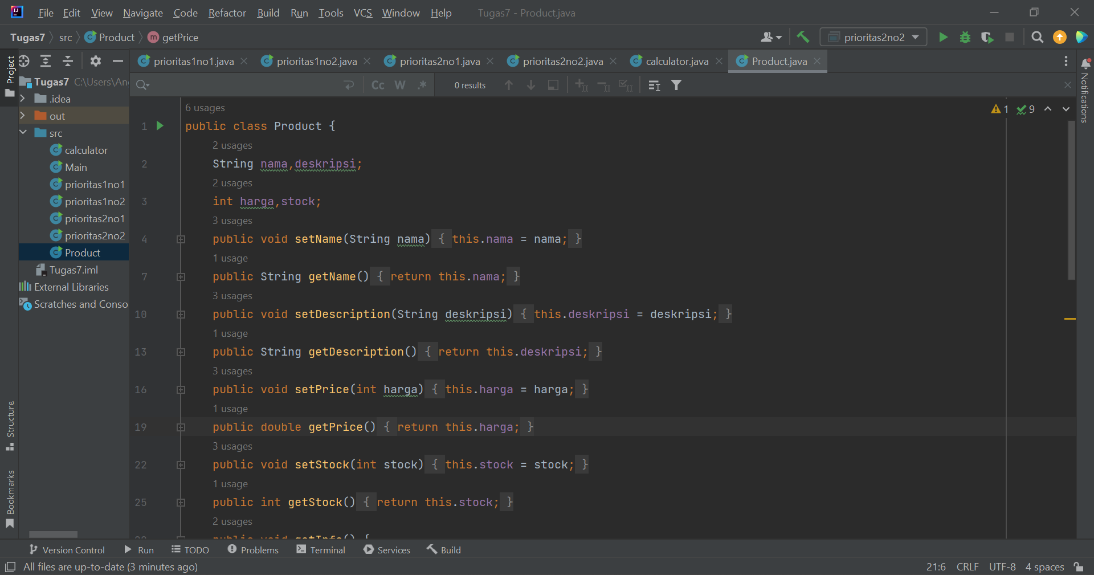

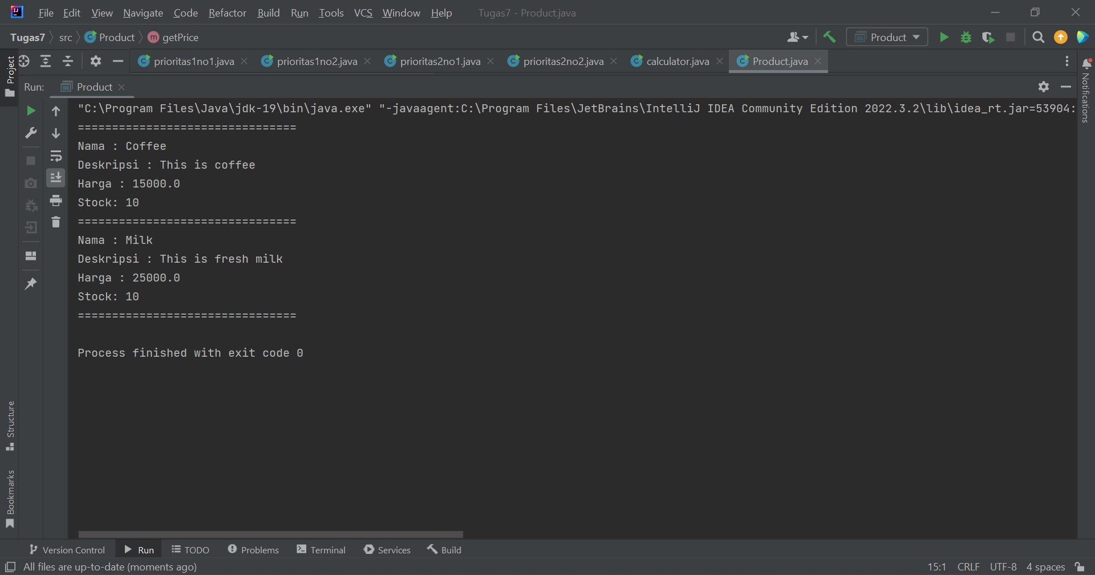

1. Source Code :

public class calculator {

public static void main(String[] args) {

int penjumlahan = penjumlahan(3,4);

int pengurangan = pengurangan(15, 4);

int perkalian = perkalian(10, 10);

int pembagian = pembagian(12, 3);

System.out.println("Hasil Penjumlahan: " + penjumlahan);

System.out.println("Hasil Pengurangan: " + pengurangan);

System.out.println("Hasil Perkalian: " + perkalian);

System.out.println("Hasil Pembagian: " + pembagian);

}

public static int penjumlahan(int a, int b) {

return a + b;

}

public static int pengurangan(int a, int b) {

return a - b;

}

public static int perkalian(int a, int b) {

return a \* b;

}

public static int pembagian(int a, int b) {

return a / b;

}

}

